Problem 1

Read in a number and print it out.

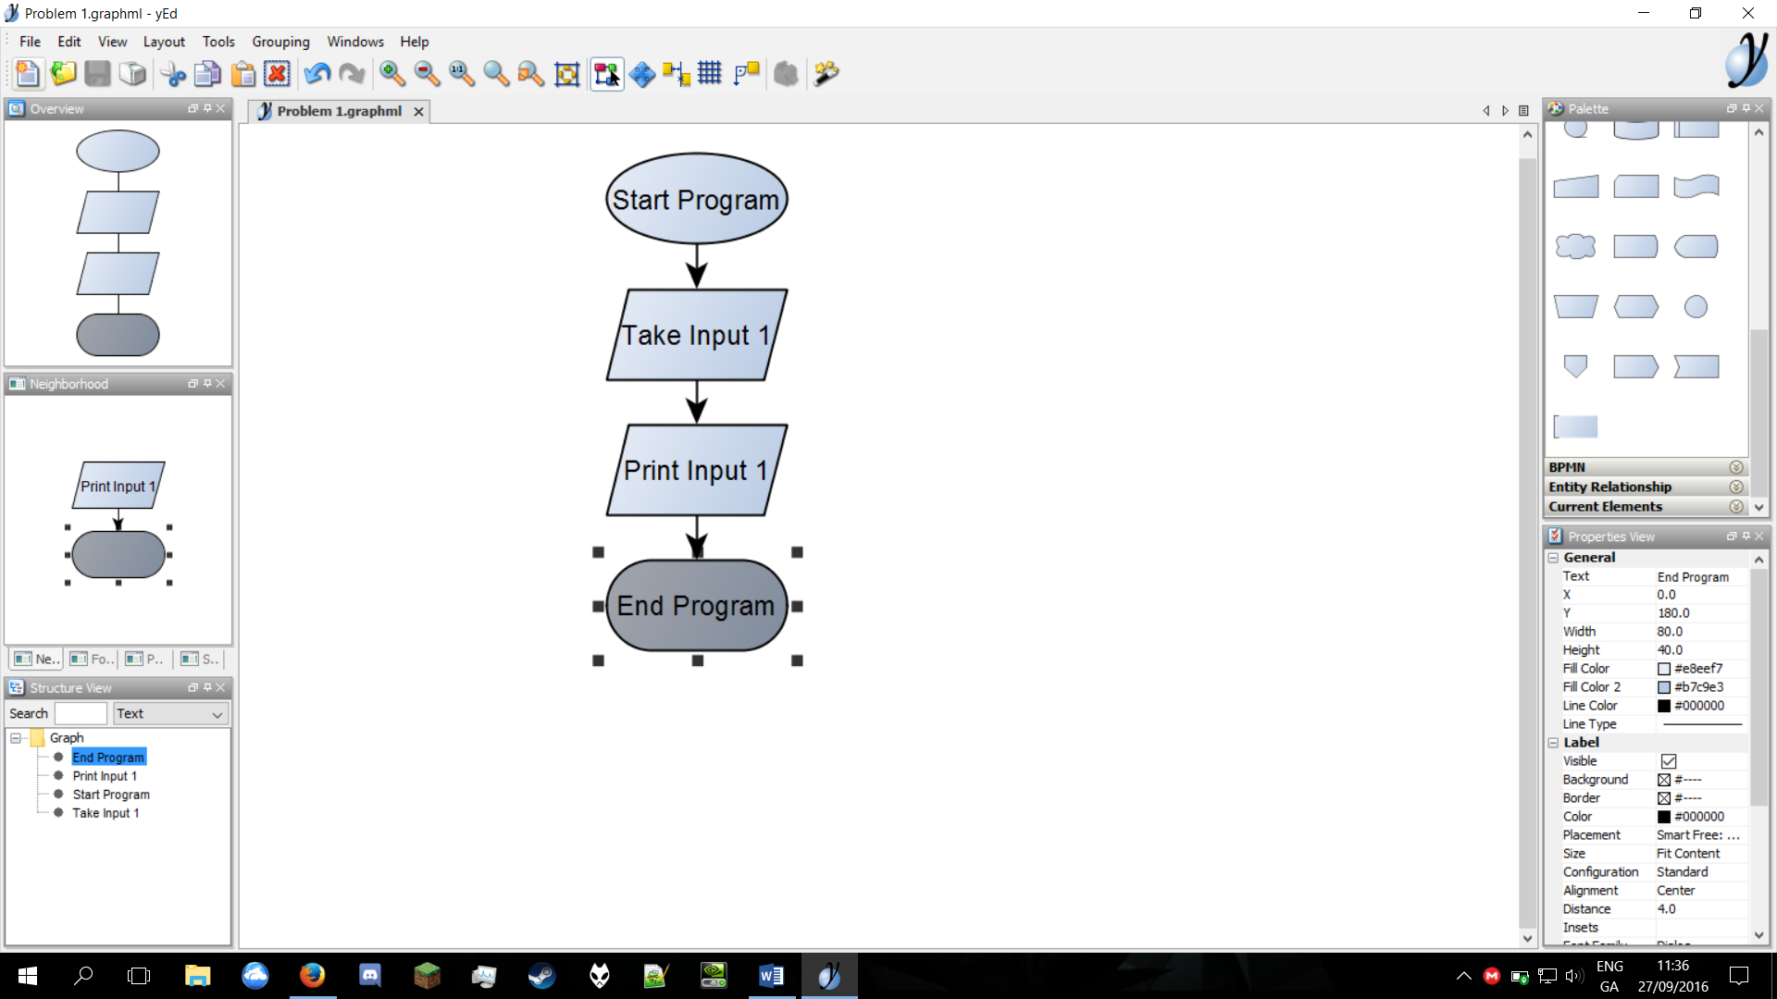

Problem 2

Read

in a number and print

out

double the

number.

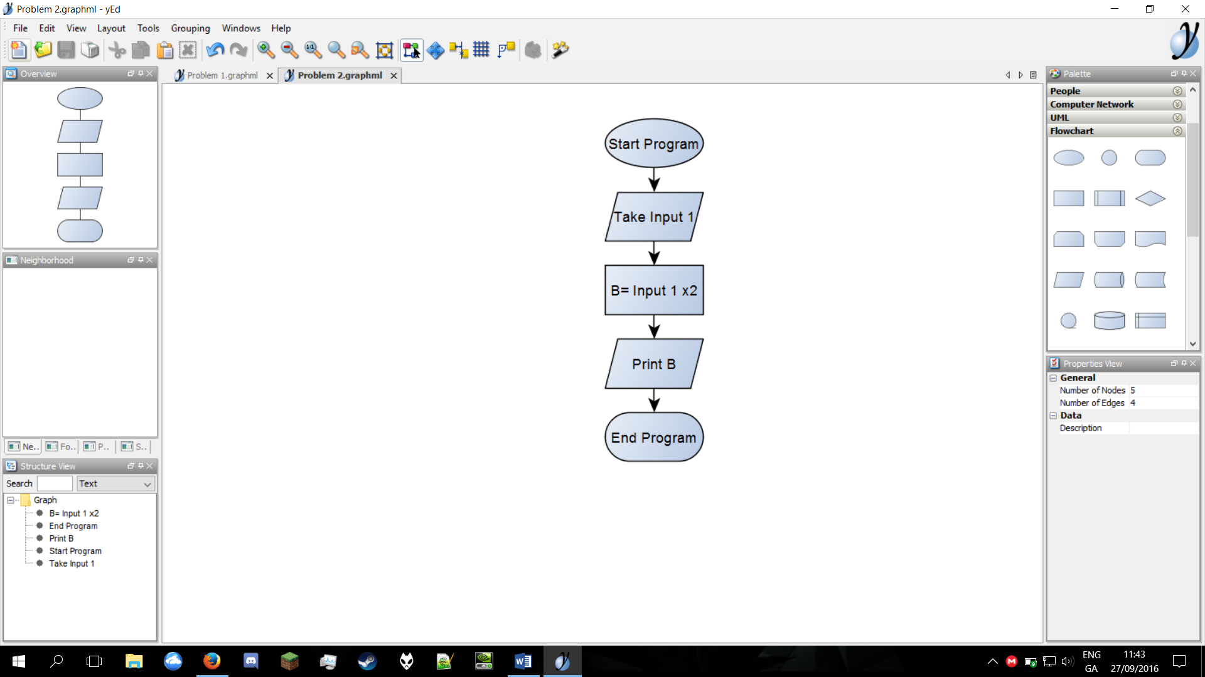

Problem 3

Read

in a number, check if it is odd or even.

